[1 0.5 1]

1 run...

Downloading: 100%

411/411 [00:00<00:00, 14.5kB/s]

Downloading: 100%

263M/263M [00:08<00:00, 32.8MB/s]

training 1 epoch...

730.146995306015 seconds used......

1 training finished! average train loss: 0.37557384455194176

evaluating...

Confusion matrix, without normalization

[[ 570 212 240]

[ 478 4674 255]

[ 433 283 10049]]

Normalized confusion matrix

[[0.55772994 0.2074364 0.23483366]

[0.08840392 0.86443499 0.04716109]

[0.04022294 0.0262889 0.93348816]]

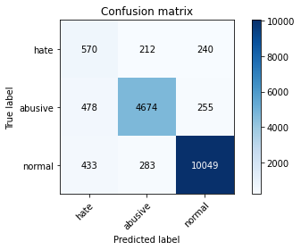

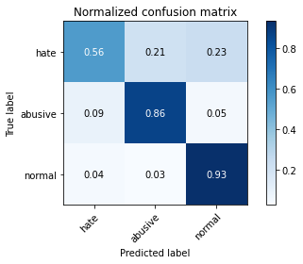

precision recall f1-score support

hate 0.38 0.56 0.46 1022

abusive 0.90 0.86 0.88 5407

normal 0.95 0.93 0.94 10765

accuracy 0.89 17194

macro avg 0.75 0.79 0.76 17194

weighted avg 0.90 0.89 0.90 17194

average eval_loss: 0.30259742482543683, accuracy: 0.8894381761079446

training 2 epoch...

729.4463768005371 seconds used......

2 training finished! average train loss: 0.28634939131892323

evaluating...

Confusion matrix, without normalization

[[ 503 217 302]

[ 464 4638 305]

[ 204 258 10303]]

Normalized confusion matrix

[[0.49217221 0.21232877 0.29549902]

[0.08581468 0.85777696 0.05640836]

[0.0189503 0.02396656 0.95708314]]

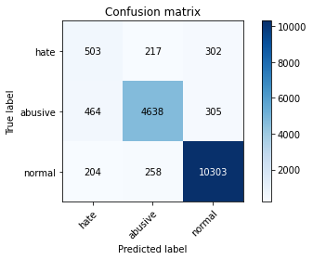

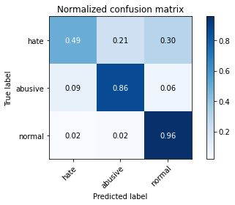

precision recall f1-score support

hate 0.43 0.49 0.46 1022

abusive 0.91 0.86 0.88 5407

normal 0.94 0.96 0.95 10765

accuracy 0.90 17194

macro avg 0.76 0.77 0.76 17194

weighted avg 0.90 0.90 0.90 17194

average eval_loss: 0.2753365120872162, accuracy: 0.8982203094102594

training 3 epoch...

728.7408442497253 seconds used......

3 training finished! average train loss: 0.20728654249539172

evaluating...

Confusion matrix, without normalization

[[ 416 280 326]

[ 276 4725 406]

[ 194 253 10318]]

Normalized confusion matrix

[[0.40704501 0.2739726 0.31898239]

[0.05104494 0.87386721 0.07508785]

[0.01802137 0.02350209 0.95847654]]

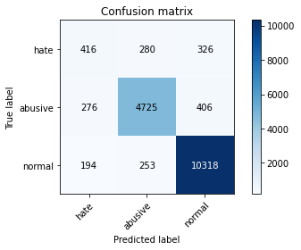

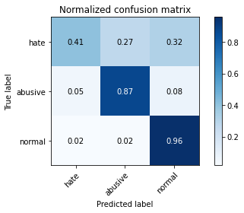

precision recall f1-score support

hate 0.47 0.41 0.44 1022

abusive 0.90 0.87 0.89 5407

normal 0.93 0.96 0.95 10765

accuracy 0.90 17194

macro avg 0.77 0.75 0.76 17194

weighted avg 0.90 0.90 0.90 17194

average eval_loss: 0.32815963142486504, accuracy: 0.8990927067581714

training 4 epoch...

729.8567001819611 seconds used......

4 training finished! average train loss: 0.1349480689009597

evaluating...

Confusion matrix, without normalization

[[ 501 261 260]

[ 506 4688 213]

[ 393 374 9998]]

Normalized confusion matrix

[[0.49021526 0.2553816 0.25440313]

[0.09358239 0.86702423 0.03939338]

[0.0365072 0.03474222 0.92875058]]

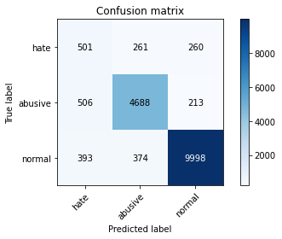

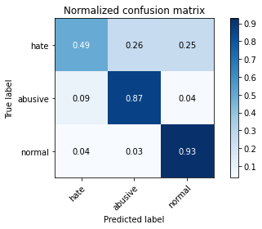

precision recall f1-score support

hate 0.36 0.49 0.41 1022

abusive 0.88 0.87 0.87 5407

normal 0.95 0.93 0.94 10765

accuracy 0.88 17194

macro avg 0.73 0.76 0.74 17194

weighted avg 0.90 0.88 0.89 17194

average eval_loss: 0.40247240004692836, accuracy: 0.883273234849366

training 5 epoch...

730.399222612381 seconds used......

5 training finished! average train loss: 0.09255571562770885

evaluating...

Confusion matrix, without normalization

[[ 456 276 290]

[ 476 4607 324]

[ 348 314 10103]]

Normalized confusion matrix

[[0.44618395 0.27005871 0.28375734]

[0.08803403 0.85204365 0.05992232]

[0.03232699 0.0291686 0.93850441]]

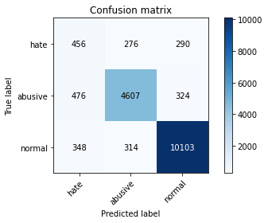

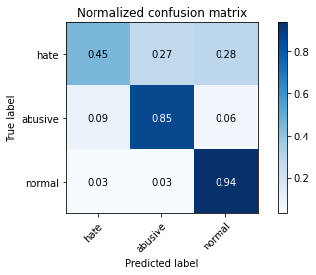

precision recall f1-score support

hate 0.36 0.45 0.40 1022

abusive 0.89 0.85 0.87 5407

normal 0.94 0.94 0.94 10765

accuracy 0.88 17194

macro avg 0.73 0.75 0.74 17194

weighted avg 0.89 0.88 0.89 17194

average eval_loss: 0.4388949029775726, accuracy: 0.8820518785622892

2 run...

training 1 epoch...

730.6299393177032 seconds used......

1 training finished! average train loss: 0.3813589263701937

evaluating...

Confusion matrix, without normalization

[[ 504 219 299]

[ 444 4681 282]

[ 261 260 10244]]

Normalized confusion matrix

[[0.49315068 0.21428571 0.2925636 ]

[0.08211578 0.86572961 0.05215461]

[0.02424524 0.02415235 0.95160242]]

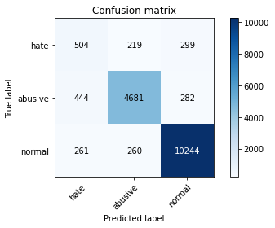

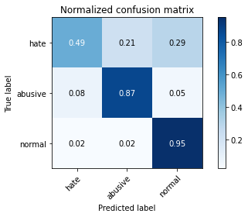

precision recall f1-score support

hate 0.42 0.49 0.45 1022

abusive 0.91 0.87 0.89 5407

normal 0.95 0.95 0.95 10765

accuracy 0.90 17194

macro avg 0.76 0.77 0.76 17194

weighted avg 0.90 0.90 0.90 17194

average eval_loss: 0.2922761827490704, accuracy: 0.8973479120623473

training 2 epoch...

730.7140033245087 seconds used......

2 training finished! average train loss: 0.2924604106413151

evaluating...

Confusion matrix, without normalization

[[ 541 164 317]

[ 776 4393 238]

[ 217 307 10241]]

Normalized confusion matrix

[[0.52935421 0.16046967 0.31017613]

[0.14351766 0.81246532 0.04401701]

[0.02015792 0.02851835 0.95132373]]

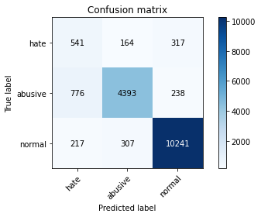

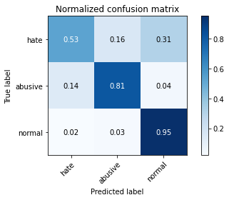

precision recall f1-score support

hate 0.35 0.53 0.42 1022

abusive 0.90 0.81 0.86 5407

normal 0.95 0.95 0.95 10765

accuracy 0.88 17194

macro avg 0.73 0.76 0.74 17194

weighted avg 0.90 0.88 0.89 17194

average eval_loss: 0.2897498116546939, accuracy: 0.8825753169710364

training 3 epoch...

730.64479637146 seconds used......

3 training finished! average train loss: 0.21122125124345775

evaluating...

Confusion matrix, without normalization

[[ 421 262 339]

[ 310 4751 346]

[ 143 277 10345]]

Normalized confusion matrix

[[0.41193738 0.25636008 0.33170254]

[0.05733309 0.87867579 0.06399112]

[0.01328379 0.02573154 0.96098467]]

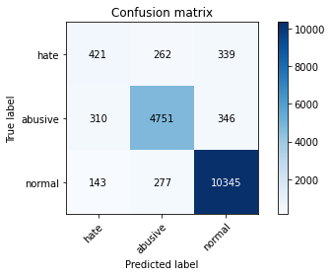

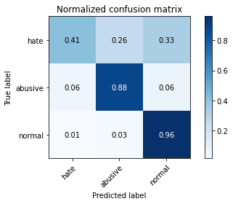

precision recall f1-score support

hate 0.48 0.41 0.44 1022

abusive 0.90 0.88 0.89 5407

normal 0.94 0.96 0.95 10765

accuracy 0.90 17194

macro avg 0.77 0.75 0.76 17194

weighted avg 0.90 0.90 0.90 17194

average eval_loss: 0.3167486671076784, accuracy: 0.9024659765034314

training 4 epoch...

730.7521786689758 seconds used......

4 training finished! average train loss: 0.13920952650975119

evaluating...

Confusion matrix, without normalization

[[ 469 267 286]

[ 387 4749 271]

[ 348 316 10101]]

Normalized confusion matrix

[[0.45890411 0.26125245 0.27984344]

[0.07157389 0.8783059 0.05012021]

[0.03232699 0.02935439 0.93831863]]

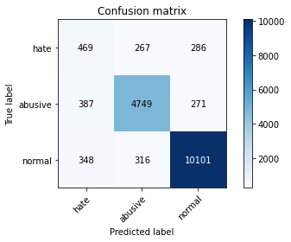

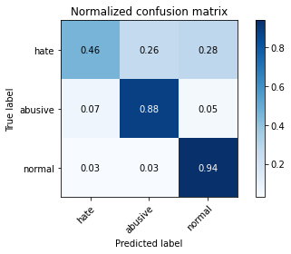

precision recall f1-score support

hate 0.39 0.46 0.42 1022

abusive 0.89 0.88 0.88 5407

normal 0.95 0.94 0.94 10765

accuracy 0.89 17194

macro avg 0.74 0.76 0.75 17194

weighted avg 0.90 0.89 0.89 17194

average eval_loss: 0.36694663861484894, accuracy: 0.8909503315109922

training 5 epoch...

731.1916155815125 seconds used......

5 training finished! average train loss: 0.09438758371981637

evaluating...

Confusion matrix, without normalization

[[ 488 281 253]

[ 448 4717 242]

[ 439 386 9940]]

Normalized confusion matrix

[[0.47749511 0.27495108 0.24755382]

[0.08285556 0.87238765 0.0447568 ]

[0.04078031 0.03585694 0.92336275]]

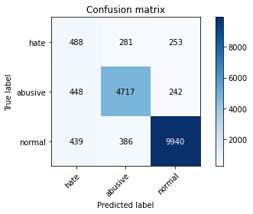

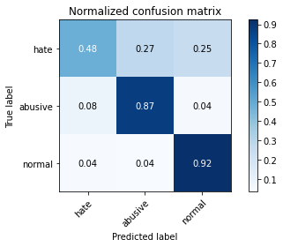

precision recall f1-score support

hate 0.35 0.48 0.41 1022

abusive 0.88 0.87 0.87 5407

normal 0.95 0.92 0.94 10765

accuracy 0.88 17194

macro avg 0.73 0.76 0.74 17194

weighted avg 0.89 0.88 0.89 17194

average eval_loss: 0.47141881880626557, accuracy: 0.8808305222752123